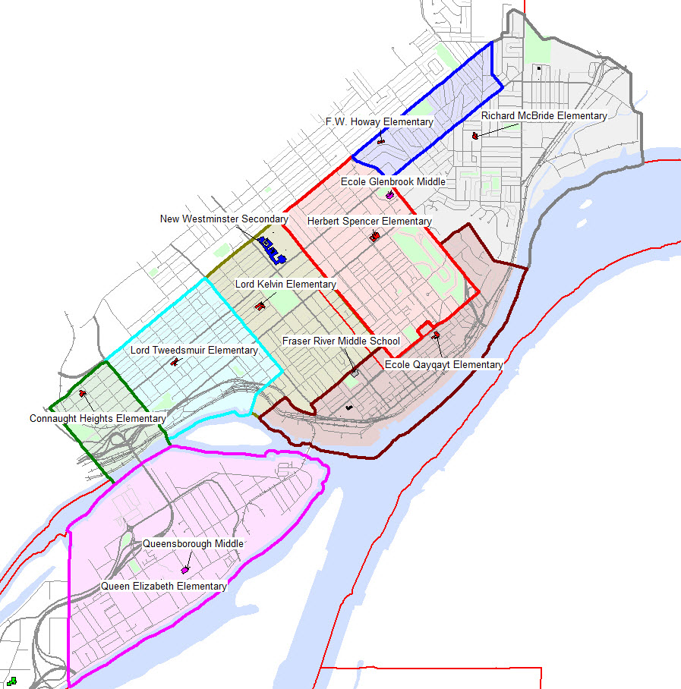
Connaught Heights Elementary | 2201 London Street, V3M 3G1 | Ph.: 604-517-6010
Fraser River Middle | 800 Queens Avenue, V3M 0J2 | Ph.: 604-517-0440
FW Howay Elementary | 91 Courtney Crescent, V3L 4M1 | Ph.: 604-517-6020
Glenbrook Middle | 701 Park Crescent, V3L 5V4 | Ph.: 604-517-5940
Herbert Spencer Elementary | 605 Second Street, V3L 5R9 | Ph.: 604-517-6030
Lord Kelvin Elementary | 1010 Hamilton Street, V3M 2M9 | Ph.: 604-517-6060
Lord Tweedsmuir Elementary | 1714 Eighth Avenue, V3M 2S7 | Ph.: 604-517-6070
New Westminster Secondary | 835 Eighth Street, V3M 3S9 | Ph.: 604-517-6220
Qayqayt Elementary | 85 Merivale Street, V3L 0G2 | Ph.: 604-517-6050
Queen Elizabeth Elementary | 921 Salter Street, V3M 6A8 | Ph.: 604-517-6080
Queensborough Middle | 833 Salter Street, V3M 6G8 | Ph.: 604-517-6040
Richard McBride Elementary | 331 Richmond Street, V3L 4B7 | Ph.: 604-517-6090

